**Reservoir continuum days** (RCD? Need a better acronym…?!):

**Overarching goal:** Assess how N, P, Chla, and DOC (quantity and quality) change over a two-reservoir gradient (from BVR inflows to FCR ouflow). The main goal is to assess changes spatially over a seasonal basis (May – September) while also capturing variations in residence time and oxic/anoxic conditions.

**The details:**

*Sampling time points:* designed to capture seasonal, residence times, and oxygen gradients

1. Regularly scheduled monthly sampling in: May, June, July, August, September (n = 5 samplings)
2. Adaptive sampling: have 3-4 additional samplings to capture flow and oxygen (oxic/anoxic experiment) gradients
3. 1 adaptive sampling in May (or early June): to capture the onset of anoxia (i.e., sample the reservoir continuum once FCR starts to become anoxic, but before the oxygenation system is turned on) compared to right after the oxygenation system is turned on (one of these time points would represent an ‘normal’ sampling; one time point would be ‘adaptive’)
4. 1 adaptive sampling in September – to capture a hurricane (or other multi-rain event) when residence time in the system decreases
5. 1-2 additional adaptive samplings in June-August: designed to either capture additional switches in oxygen or changes in residence time (dependent on rain fall, oxygenation experiments, how previous samplings have gone, field morale, general logistics and scheduling conflicts)

*Sampling locations:* designed to capture the full two-reservoir continuum (and the pipeline!) (total locations = 18-19)

BVR: (thanks Whitney for the maps!)

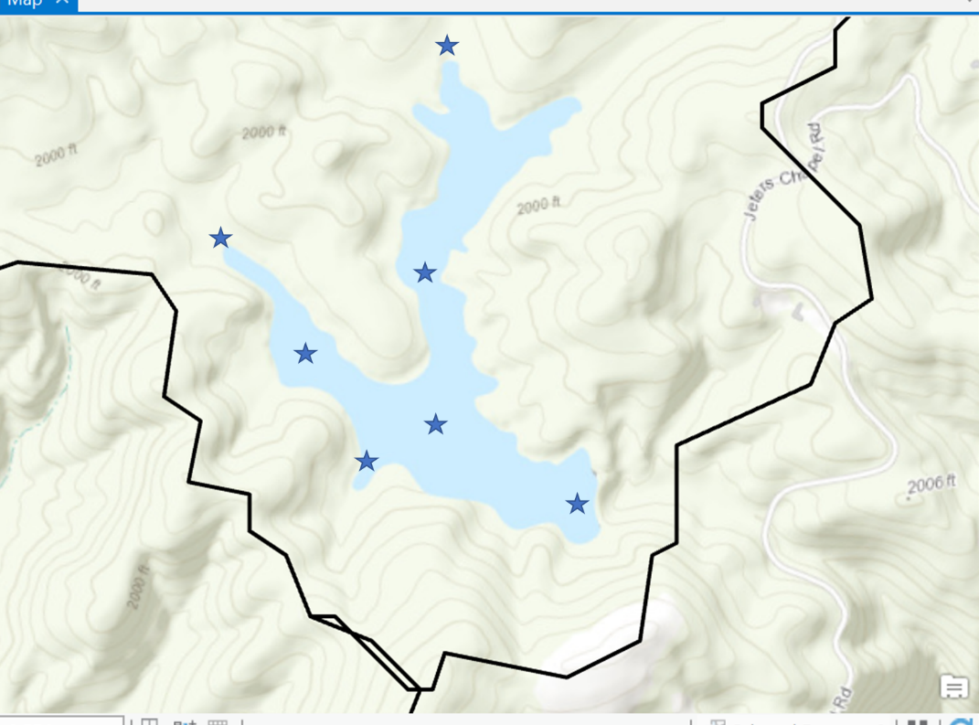

BVR highlights/location justification (n = 7 locations):

* Need to capture inflows to the left and right arms (in terms of knowing what’s coming in but also for BVR hydrology = two birds, one stone)
* Want to sample an additional location in each arm to capture any ‘processing’ within each system
* Then also capture a location at the confluence to see how these two arms ‘meet’
* Most importantly, need to capture the outflow from BVR before entering the underground pipe
* And sample at existing station 50 (mainly just because/for comparisons to deep hole in FCR under changing oxygen conditions)

Stream + FCR: (again, thanks Whitney!)

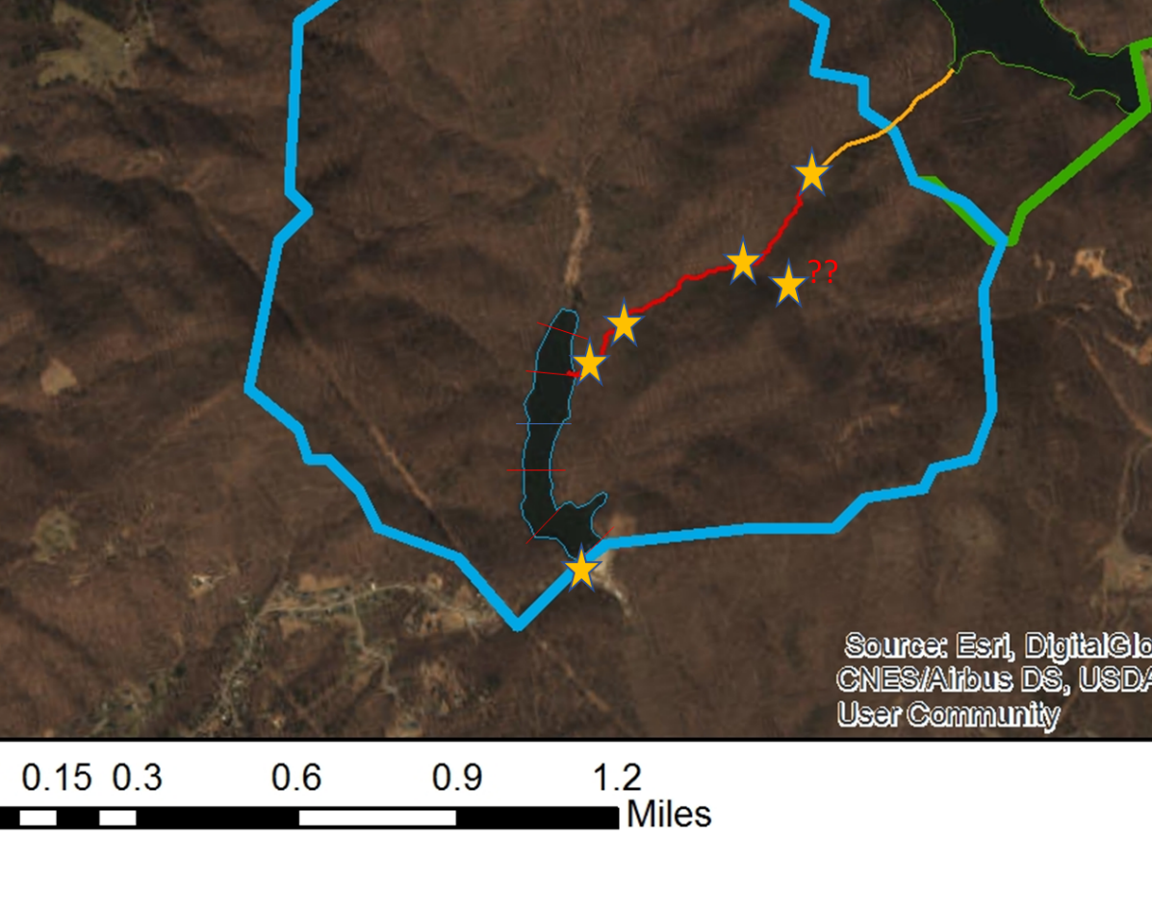

Stream + FCR highlights/location justification:

* 1. Stream (n = 5 locations)
     + Must capture outflow immediately from the closed pipe (what the heck is going on in the dark??) yes!
     + Sample at a location between the pipeline outflow and the weir
     + Sample the forked stream (??) – this may be important under conditions when BVR is actually not connected to FCR
     + Sample at the weir (if we’re going to have continuous –ish discharge there anyway) = yes!
     + Sample right before the stream enters FCR
  2. FCR (n = 6-7 locations)
     + Mainly just sample the current sampling locations in FCR (wetland or 10, 20, 30, 45, 50)
     + Then add a sampling location for the spillway
     + Add station 25 on reservoir continuum days

*Parameters collected:* surface only (0.1 m)!

YSI cast (again, surface only!)

Total nutrients (N, P)

Dissolved nutrients (N, P, DOC)

OM quality (combusted, glass vial, filtered in field – essentially same protocol as DOC)

Filtered Chl-a

BDOC experiments (something to think about…may be good to conduct BDOC experiments on subset of time points, locations, etc.)

*Personnel and logistics:*

Have two sampling teams for each reservoir continuum day:

Team 1 (2-3 people): Sampling FCR and stream reach using small boat w/ electric motor (may be able to rent fleet car for the day?)

Team 2 (3 people): Sampling BVR using john boat

I count up to 20 sites x 10 days = 400 samples assuming you do 2 reps at each site. That’s a lot of samples! My question for you two is: what is more important, fewer sites but more days or more sites but fewer days? (space vs time, the eternal tradeoff…)

At a bare minimum, I think that you could go down to 5 sites at BVR (2 stream inflows, mid-left arm, 50, outflow to FCR) and then 10 sites in (pipe outlet, mid-stream, weir, stream entering FCR, wetland/10, 20, 30, 45, 50, spillway) = 15 sites. That would only result in 300 samples, which would save you many days in the lab. Something for you two to consider?